Western Bluebird

A common bird in the thrush family. Its preferred habitat is where there is a mixture of trees and open areas, as with the grassland and woodland mosaic situation at Arroyo Hondo Preserve. They move around in small groups and feed on insects and fruit. The male has bright blue wings and tail and an orange breast, while females have more subdued coloration. Juveniles have markedly spotted feathers. At Arroyo Hondo, our bluebird boxes have had active nests for the last few years.

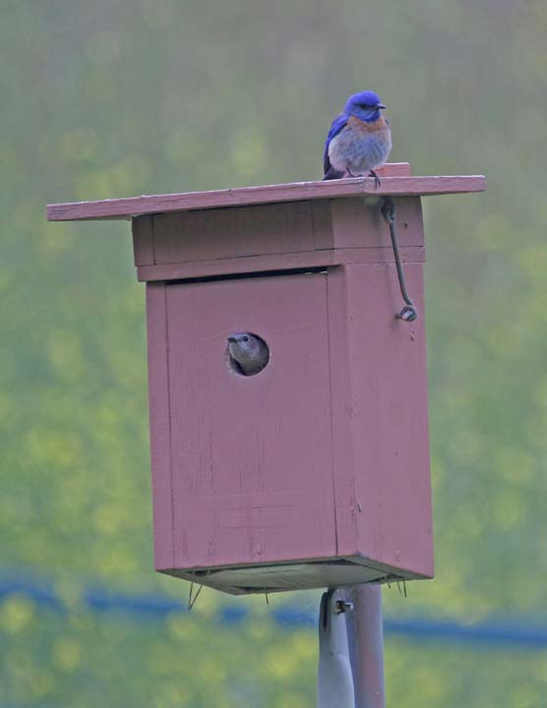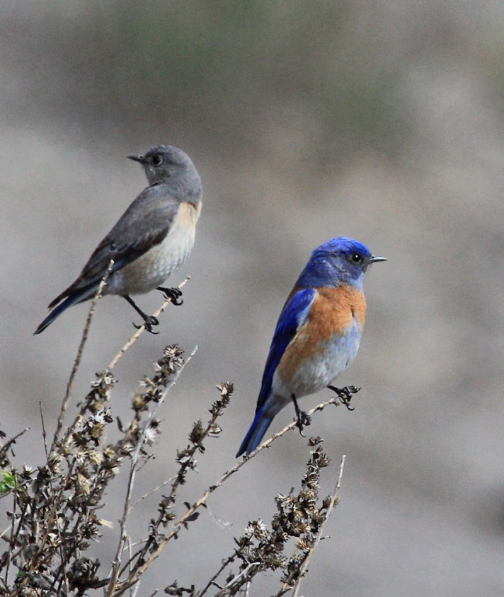

Reference: The Sibley Field Guide to Birds of Western North America

